

The Corporation of the Municipality of Powassan
Re: Minor Variance to seek relief from provisions of Zoning By-law 2003-38 in accordance with Section 45(1) of the Planning Act
File #: 2026-03
Applicant: Marcus ODD, Josee LEVESQUE

Location of Property: 37 Golf Course Line, Lot 11, Concession 16; Former geographic Township of Himsworth, District of Parry Sound, Municipality of Powassan (Refer to key map).

Present Status of Land Subject to Application: The lands are zoned Rural (RU) Zone and are vacant.

Purpose and Effect of the Application: The Applicant proposes to construct a new dwelling at the south portion of the property and requires the following variance to Zoning By-law 2003-28: Section 4.4.2 iv) minimum interior side yard setback = 15 metres (49.2 feet). The proposed dwelling would be located 4.5 metres (15 feet) from the east interior side lot line, requiring variance of 10.5 metres (35 feet).

Additional Information: If you require additional information or have any questions with respect to this application please contact Ms. Kimberly Bester, Secretary-Treasurer at 705-724-2813.

TAKE NOTICE THAT an application under the above file number will be heard by the Committee of Adjustment on the date and time and place shown below, under the authority of Section 45 of the Planning Act.
FRIDAY, JULY 10, 2026 – 6:10 PM
MUNICIPALITY OF POWASSAN
250 MAIN CLARK ST., POWASSAN ONTARIO

PUBLIC HEARING: You are entitled to attend this hearing in person, or you may be represented by Counsel or an Agent to give evidence about the application. Signed, written submissions that relate to this application shall be accepted by the Secretary-Treasurer before or during the hearing of the application at the address above and shall be available to any interested person for inspection prior to or at the hearing.

FAILURE TO ATTEND: If you do not attend at this Public Hearing, it may proceed in your absence and except otherwise provided in the Planning Act, you will not be entitled to any further notice in the proceedings.

IF A SPECIFIED PERSON as per the Planning Act would otherwise have an ability to appeal the decision to the Ontario Land Tribunal (OLT) but the person or public body does not make oral submissions at a public meeting or make written submissions before the by-law is passed, the person or public body is not entitled to appeal the decision.

NOTICE OF DECISION: A certified copy of the decision, together with a notice of the last day of appealing to the Ontario Land Tribunal shall be sent, no later than 20 days from the making of the decision, to the applicant, and to each person who appeared in person or by counsel at the hearing and who filed a request for notice of the decision. Additional information on appeals should be directed to the Secretary-Treasurer of the Committee of Adjustment.

Dated this 22ND DAY OF JUNE 2026
Ms. Kimberly Bester, Secretary-Treasurer
Powassan Committee of Adjustment
Box 250, Powassan ON P0H 1Z0

KEY MAP

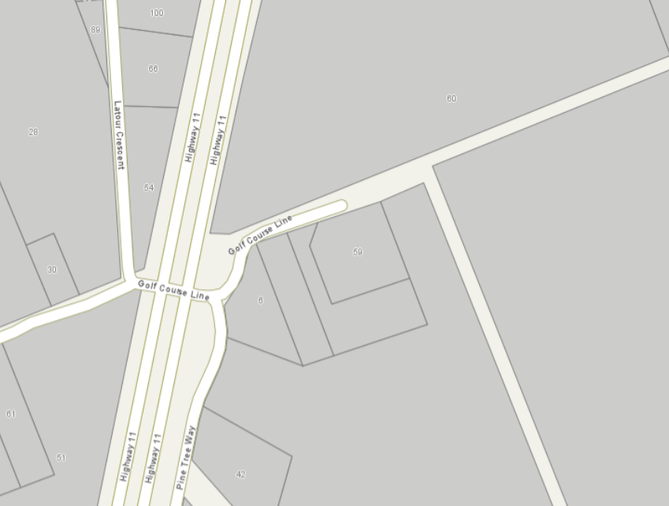
Subject Lands
37 Golf Course Line

SITE PLAN
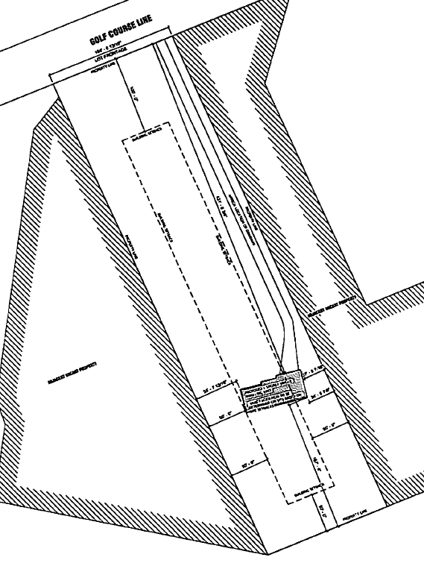
N
Proposed Dwelling

